 | The Italian Game Tour… to 30 prizes!!!  Giro d’ Italia Ludico | Vor- & Zuname / First- & sur-  name / Nome & cognome: | Geburtsdatum / Birth-  day / Data di nascita:

Lass dir neue Spiele erklären, probiere sie aus… und lass diesen Flyer abstempeln! Für jede Erklärung gibts 1 Stempel (entspricht 1 Los), fürs Spielen 2 Stempel (3 Lose). Wirf den Flyer bis 16:30 am Stand 9-57 von H@LL 9000 ein (Preisverleihung: 17:00)!
Let explain new games, try them… and let stamp this flyer! For every explanation you get 1 stamp (counts 1 lottery ticket), for playing 2 stamps (3 tickets). Drop in the flyer until 4:30 PM at booth 9-57 from H@LL 9000 (prize-giving: 5:00 PM)!
Lascia spiegare nuovi giochi, provali… e lascia timbrare questo volantino! Per ogni spiegazione ricevi 1 timbro (vale 1 sorte), x giocare 2 timbri (3 sorti). Imbuca il volantino fino a 16:30 allo stand 9-57 di H@LL 9000 (premiazione: 17:00)!

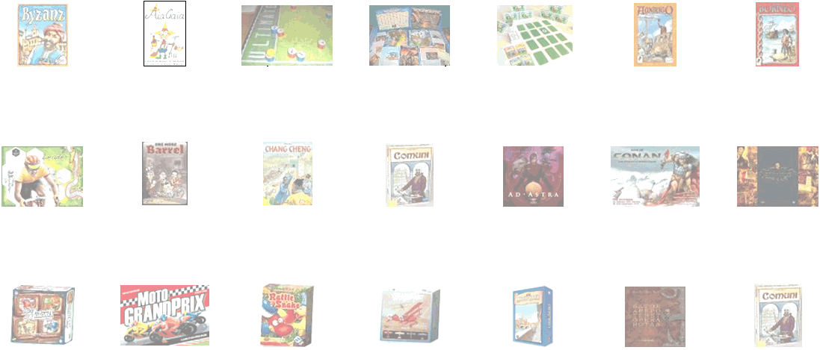Amigo (11-22): | Pixel Multimedia: | Angelo Porazzi Games (9-30): |  | Alex-Games: | dv Editrice (10-40):
Byzanz  3-6 | 8-99| 45 | AiaGaia  2-8 | 5-99 | 10 | Ultimate  2 | ?-99 | 20 | Warangel  (Spartani/Persiani)  2-6 | 10-99 | 90 | Wizards  of Soccer  2 | 6-99 | 15 | Amerigo  2-4 | ?-99 | ? | Borneo  3-5 | ?-99 | 45
Ghenos Games  (4-318): | Giochix.it Edizioni  (5-89): | Huch & friends (12-89): |  | Nexus Editrice - Prototypen (12-56):
Leader 1  1-14 | 14-99 | 90 | One More  Barrel  3-5 | 12-99 | 90 | Chang Cheng  2-4 | 12-99 | 60 | Comuni  2-5 | 12-99 | 90 | Ad Astra  2-5 | ?-99 | 90 | Age of Conan  2-4 | 12-99 | 180 | Battles of Napoleon  2 | 12-99 | 90
Nexus Editrice (12-56): |  |  |  | Red Glove (10-55): | Scribabs (9-42): | Tenkigames  (12-56):
Micro  Mutants  2-4 | 10-99 | 30 | MotoGrandPrix  2-6 | 8-99 | 60 | Rattlesnake  2-4 | 6-99 | 15 | Wings of War  Miniatures (II/III)  2-4 | 10-99 | 45 | Lungarno  2-5 | 8-99 | 45 | Sator...  2-4 | 9-99 | 50 | Comuni  2-5 | 12-99 | 90

